Montgomery County Department of Transportation
Ride On Transit Services
July 2, 2024
6:30 p.m.

`
Public Forum

PUBLIC FORUM
Overview

Montgomery County Department of Transportation, Ride On Transit Services is proposing changes to Routes 43, 63, and 66. As part of the county’s commitment to receive comments from the public, a public forum is being conducted on the proposed changes. This process allows Montgomery County Department of Transportation, MCDOT, to gather the most information possible regarding the proposed service changes which will provide the best opportunity for success.

Beginning on September 8, 2024, the new Great Seneca Ride On extRa will provide high-frequency service to the Great Seneca Life Science corridor. The adjustments to Routes 43, 63, and 66 will provide more efficient and direct local service to and within the area.

It is important to note, staff continues to monitor the Ride On routes routinely to effectively gauge the pre-Covid and post Covid trends. As ridership trends continue to develop and resources become available we are in a position to readily meet the demand.

Individuals and representatives of organizations who wish to submit comments regarding this public forum may do so by submitting in writing or by email no later than July 12, 2024. This information can be mailed and/or emailed to:

Division of Transit Services
Ride On Public Forum
101 Monroe Street, 5th Floor
Rockville, MD 20850
240-777-5800
mcdot.rideonpublicforums@montgomerycountymd.gov

Title VI: Montgomery County assures that no person shall, on the grounds of race, color, or national origin, as provided by Title VI of the Civil Rights Act of 1964 and the Civil Rights Act of 1987, be excluded from the participation in, be denied the benefits of, or be otherwise subjected to discrimination under any program or activity.

Route 43 |  |  | Existing | Proposed
From |  |  | Shady Grove Metro Station | Shady Grove Metro Station
To |  |  | Traville Transit Center | Traville Transit Center
Span | Weekday |  | 5:00 am – 11:50 pm | 5:00 am – 11:50 pm
 | Saturday |  | 6:30 am – 9:30 pm | 6:30 am – 9:30 pm
 | Sunday |  | 6:30 am – 9:30 pm | 6:30 am – 9:30 pm
Headway  (Minutes) | Weekday | AM Peak | 25 min | 25 min 30 min
 |  | Midday | 30 min | 30 min
 |  | PM Peak | 25 min | 25 min
 |  | Evening | 50 min | 30 min
 |  | Late Night | 50 min | 30 min
 | Saturday |  | 35 min | 35 min
 | Sunday |  | 35 min | 35 min
Description of Proposal |  |  | Service will be added to Gaither Road west of Shady Grove Road to replace the current Route 63 service.  The route will no longer enter the Shady Grove Adventist Hospital property. Service to the hospital will be provided at stops on Medical Center Drive.  Service between the hospital and Traville Transit Center will be provided along Medical Center Drive, Great Seneca Highway, and Darnestown Road. There will be no Route 43 service on Shady Grove Rd between Darnestown Road and Fallsgrove Boulevard; Routes 45, 56, and 301 will continue to serve this location.
Justification for Proposal |  |  | Provide more efficient and direct service between Shady Grove and Traville, and address future development at the hospital.

Proposed Route 43 Map
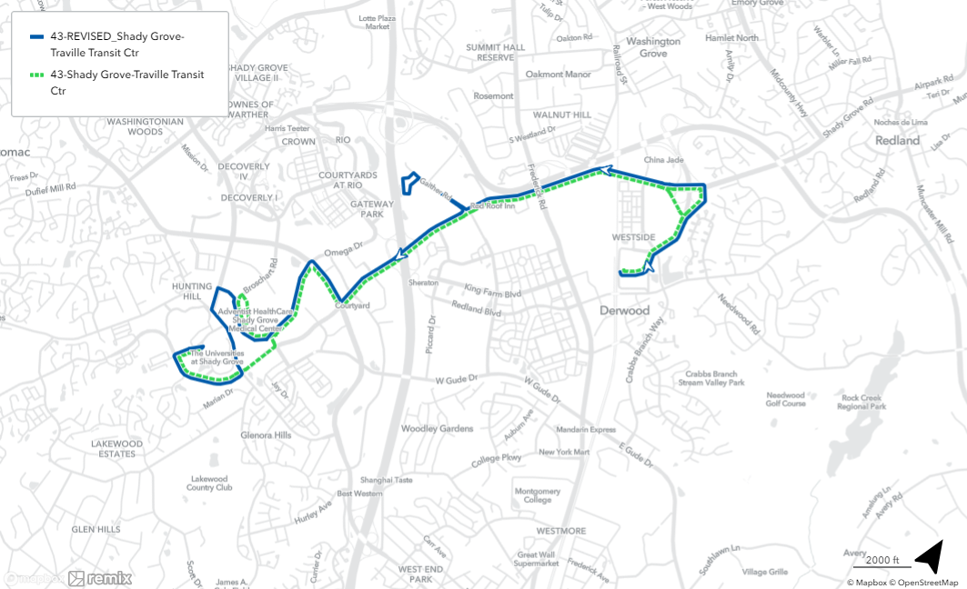

Route 63 |  |  | Existing | Proposed
From |  |  | Shady Grove Metro Station | Shady Grove Metro Station
To |  |  | Rockville Metro Station | Rockville Metro Station
Span | Weekday |  | 5:45 am – 8:20 pm | 5:45 am – 8:20 pm
 | Saturday |  | - | -
 | Sunday |  | - | -
Headway  (Minutes) | Weekday | AM Peak | 35 min | 35 min
 |  | Midday | 35 min | 35 min
 |  | PM Peak | 35 min | 35 min
 |  | Evening | - | -
 |  | Late Night | - | -
 | Saturday |  | - | -
 | Sunday |  | - | -
Description of Proposal |  |  | The route will no longer serve Gaither Road. Buses will remain on Redland Road between the Shady Grove Metro Station and Piccard Drive.  Route 43 will serve Gaither Road west of Shady Grove Road, and Route 66 will serve Gaither Road between Redland Blvd and Piccard Dr.
Justification for Proposal |  |  | Provide more efficient and direct service between Shady Grove and Rockville

Proposed Route 63 Map
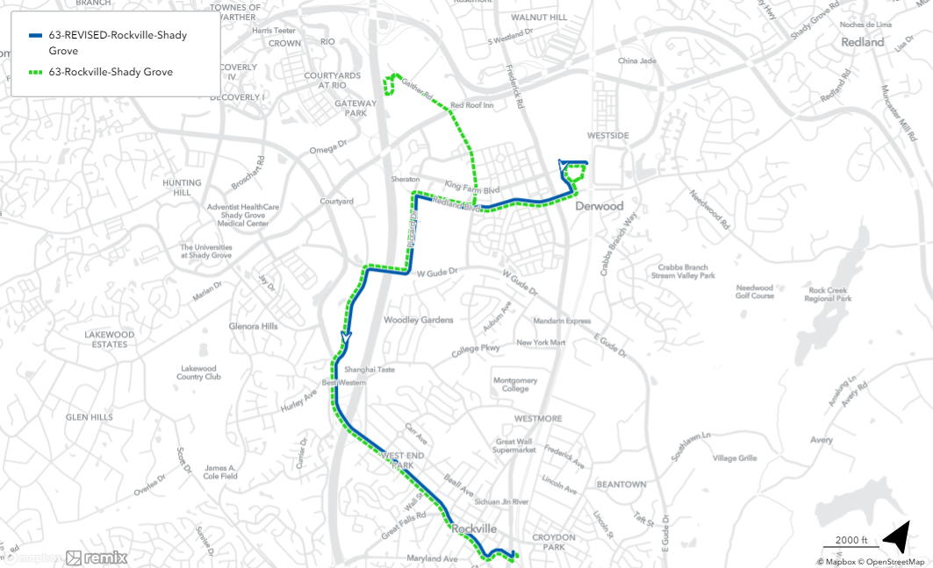

Route 66 |  |  | Existing | Proposed
From |  |  | Shady Grove Metro Station | Shady Grove Metro Station
To |  |  | Traville Transit Center | Traville Transit Center
Span | Weekday |  | 5:20 am – 8:50 am  3:15 pm – 6:50 pm | 5:20 am – 8:50 am  3:15 pm – 6:50 pm
 | Saturday |  | - | -
 | Sunday |  | - | -
Headway  (Minutes) | Weekday | AM Peak | 35 min | 35 min
 |  | Midday | - | -
 |  | PM Peak | 35 min | 35 min
 |  | Evening | - | -
 |  | Late Night | - | -
 | Saturday |  | - | -
 | Sunday |  | - | -
Description of Proposal |  |  | Service will be added to Gaither Road between Redland Boulevard and Piccard Drive, and on Piccard Drive between Gaither Road and Redland Boulevard. Route 63 will provide service on Redland Boulevard between Gaither Road and Piccard Drive.  The route will no longer enter the Shady Grove Adventist Hospital property. Service to the hospital will be provided at stops on Medical Center Drive.
Justification for Proposal |  |  | Maintain transit service on portions of Gaither Road, and address future development at the hospital.

Proposed Route 66 Map
